**Assignment**

**Module–4(Advancepythonprogramming)**

1. **WhatisFilefunctioninpython?Whatiskeywords tocreate and write file.**

-> Files in Python can be opened with a built-in open() function. To createafileinPython,youcanusethe open() functionwiththe'a'mode such as file = open('myfile. txt', 'a') .

1. **WriteaPythonprogramtoreadanentiretextfile.**

**Code:**

deffile_read(fname): txt = open(fname) print(txt.read()) file**_read("test.txt")**

# 3.WriteaPythonprogramtoappendtexttoafileanddisplay the text.

**Code:**

efile_read(fname):

fromitertoolsimportislice

with open(fname, “w”) as myfile: myfile.write(“Pythonprogramming\n”) myfile.write(“Java programming”)

txt=open(fname) print(txt.read())

file_read(‘abc.txt’)

**Output:**

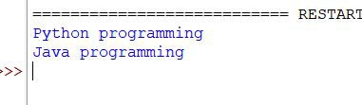

# 4.WriteaPythonprogramtoreadfirstnlinesofafile.

**Code**:

deffile_read_from_head(fname,nlines): from itertools import islice

withopen(fname)asf:

forlineinislice(f,nlines): print(line)

file_read_from_head('test.txt',2)

# 5.WriteaPythonprogramtoreadlastnlinesofafile.

**Code:**

defLastNlines(fname,N):

withopen(fname)asfile:

forlinein(file.readlines()[-N:]): print(line, end ='')

if name == ' main ': fname = 'test.txt'

N =3

try:

LastNlines(fname,N) except:

print('Filenotfound')

**Output:**

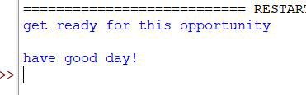

**6.WriteaPythonprogram toreadafilelinebylineandstore it into a list**

**Code:**

efile_read(fname):

withopen(fname)asf:

#Content_lististhelistthatcontainsthereadlines. Content_list = f.readlines()

print(content_list) file_read(‘test.txt’)**Output:**

# 7.WriteaPythonprogram toreadafilelinebylinestoreit into a variable.

**Code:**

deffile_read(fname):

withopen(fname,"r")asmyfile: data=myfile.readlines() print(data)

file_read('test.txt')

**Output:**

# 8.Writeapythonprogramtofindthelongestwords.

**Code:**

deflongest_word(filename):

withopen(filename,'r')asinfile: words=infile.read().split()

max_len=len(max(words,key=len))

return[wordforwordinwordsiflen(word)==max_len] print(longest_word('test.txt'))

**Output:**

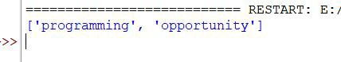

# 9.WriteaPythonprogramtocountthenumberoflinesina text file.

**Code:**

def file_lengthy(fname): withopen(fname)asf:

fori,linenumerate(f): pass

returni+1

print("Numberoflinesinthefile:",file_lengthy("test.txt"))

**Output:**

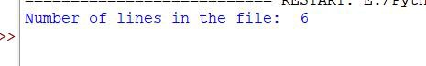

# 10.WriteaPythonprogramtocountthefrequencyofwords in a file.

**Code:**

fromcollectionsimportCounter def word_count(fname):

withopen(fname)asf:

returnCounter(f.read().split())

print(“Numberofwordsinthefile:”,word_count(“test.txt”))

**Output:**

# 11.WriteaPythonprogramtowritealisttoafile.

**Code**:

color=['Red','Green','White','Black','Pink','Yellow'] with open('abc.txt', "w") as myfile:

forcincolor:

myfile.write("%s\n"%c)

content=open('abc.txt') print(content.read())

**Output:**

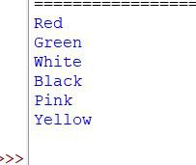

# 12.ExplainExceptionhandling?WhatisanErrorinPython?.

-> An error is an issue in a program that prevents the program from completing its task.

an exception is a condition that interrupts the normal flow of the program. Both errors and exceptions are a type of runtime error, which means they occur during the execution of a program.

# 13.Howmanyexceptstatementscanatry-exceptblockhave? Name Some built-in exception classes:

->Havemultipletryblocks inaprogrambutonlyoneexceptstatement with each try block.

# 14.Whenwilltheelsepartoftry-except-elsebeexecuted?

->Theelsepartisexecutedwhennoexception occurs.

# 15.Can one block of except statements handle multiple exception?

->Yes,asingleblockofexceptstatements inPythoncanhandlemultiple exceptions

# 16.Whenisthefinallyblockexecuted?

-> The finally block always executes when the try block exits. This ensures that the finally block is executed even if an unexpected exception occurs.

# 17.Whathappenswhen„1‟==1isexecuted?

->ItsimplyevaluatestoFalseanddoesnotraiseanyexception.

# 18.HowDoYouHandleExceptionsWithTry/Except/FinallyIn Python? Explain with coding snippets.

-> If an exception occurs during execution of the try clause, theexception may be handled by an except clause. If the exception is not handled by an except clause, the exception is re-raised after the finally clause has been executed.

# 19.Write python program that user to enter only odd numbers, else will raise an exception.

**Code:**

classEvenNumberException(Exception): pass

defget_odd_number(): while True:

try:

user_input=int(input(“Enteranoddnumber:”)) if user_input % 2 == 1:

returnuser_input else:

raiseEvenNumberException(“Enterednumberiseven.Please enter an odd number.”)

exceptValueError:

print(“Invalidinput.Pleaseenteravalidinteger.”)

try:

odd_number=get_odd_number()

print(f”Youenteredanoddnumber:{odd_number}”) except EvenNumberException as e:

print(f”Error:{e}”)

**Output:**

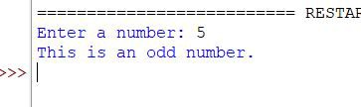

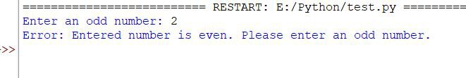

# 20.Whatareoopsconcepts?Ismultipleinheritance supported in java

-> OOP concepts include abstraction, encapsulation, inheritance and polymorphism. Basically, Java OOP concepts let us create working methods and variables, then re-use all or part of them without compromising security

->Java doesn’t support Multiple Inheritance, but we can use interfaces (instead of classes) to achieve the same purpose.

# 21.HowtoDefineaClassinPython?WhatIsSelf?GiveAn Example Of A Python Class

-> Objects are instances of a class, and they can have attributes (characteristics) and methods (functions) associated with them. The self parameter is used to refer to the instance of the class itself within its methods.

# 22.Write a Python class named Rectangle constructed by a length and width and a method which will compute the area of a rectangle.

**Code:**

classRectangle():

def init (self,l,w): self.length = l self.width= w

def rectangle_area(self): returnself.length*self.width

newRectangle = Rectangle(12, 10) print(newRectangle.rectangle_area())

**Output:**

